Welcome to the next Young Art competition and exhibition 2025.
We are very excited to announce this year's theme for our competition is. 'Faces & Places'.
This year's exhibition will be held at a wonderful space gallery@oxo located on the South Bank along the River Thames in London!
We are really looking forward to receiving your fabulous entries by Friday, 17th January 2025 and look forward to seeing you at the exhibition which will be running from Tuesday, 29th April to Sunday, 4th May 2025.
We've put together some ideas of artists who might inspire you on this theme as well as some current exhibitions that would be great to draw in front of and discover!

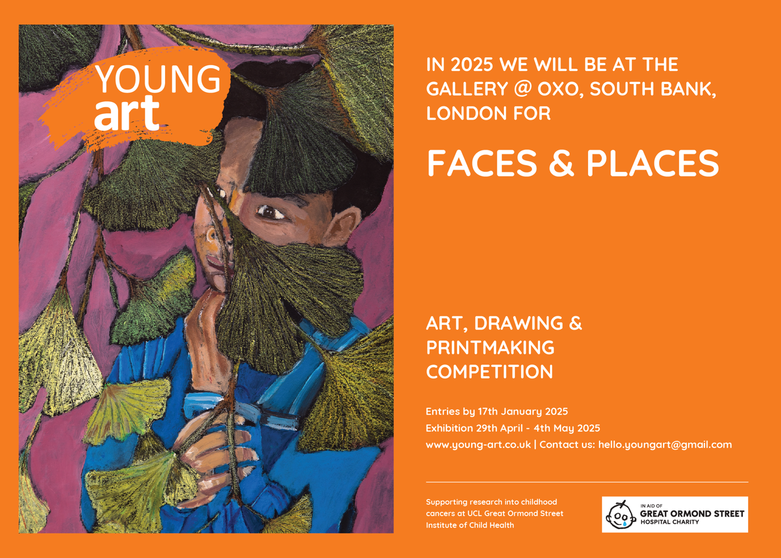

IDEAS TO INSPIRE FACES AND PLACES

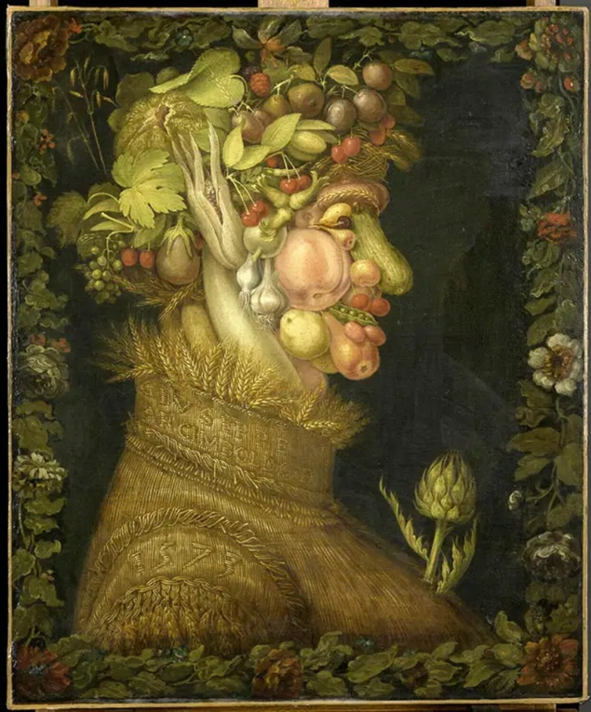
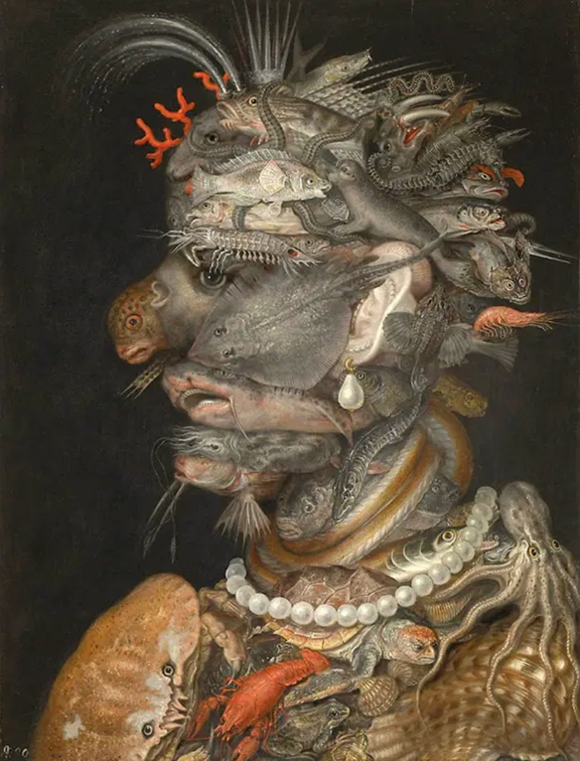

Summer from the Four Seasons (left) and Water from the Four Elements (right) by Giuseppe Arcimboldo 1573, the Louvre Museum.

Not all portraits need to be direct illustrations of people. Arcimboldo was incredibly innovative, as the court painter for the Holy Roman Emperor often tasked with painting more traditional portraits he also devised these incredible paintings of the seasons and the elements using relevant subject matter to make up his own allegorical portraits of each. With the Four Seasons, Arcimboldo created a glorified portrait of the imperial family; the diversity of plant species symbolised the Empire’s vastness and the seasonal cycle the Habsburg’s longevity.
Think imaginatively about how you could make a portrait or face of someone that is not just made of what you might expect but perhaps reflective of them in more unusual and symbolic ways.
Many of the surrealist painters hundreds of years later (see below) were hugely inspired by Arcimboldo. Be bold in your experiments and the forms you use to make up your faces!!

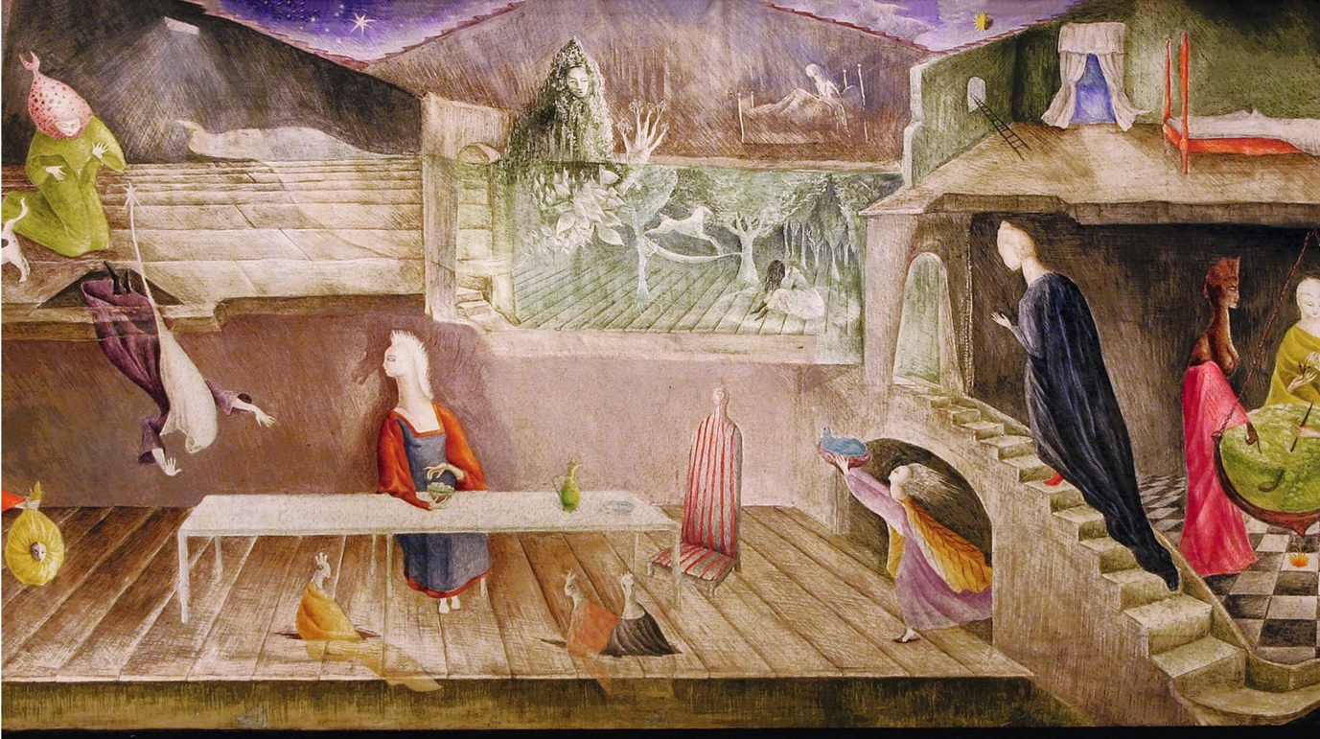
Leonora Carrington, The House Opposite, 1945

Leonora Carrington was one of the only female surrealists who was recognised by her male contemporaries as an artist in her own right and not just a 'muse'. She built her own rich and absurdly imaginative worlds. Look at her work and try and make sense of the symbols she's using... bird-headed plague doctors, sprinting waifs, golden eggs and nest-haired sibyls...what might they mean? Read some of her short stories for inspiration!
How might you build a world of symbols and codes that perhaps maybe you know how to decipher but others might also be able to relate to in their own ways!?

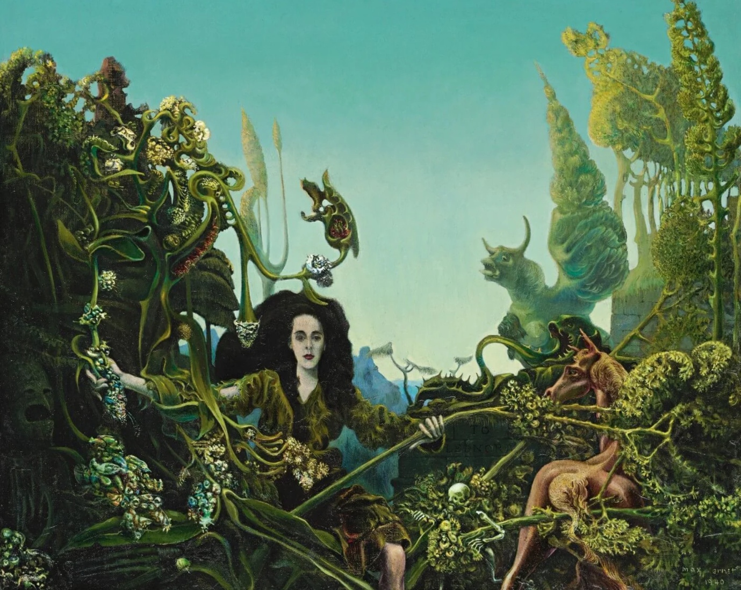
Leonora (Carrington) in the Morning Light by Max Ernst.

Max Ernst was in a relationship and helped to mentor with fellow Surrealist Leonora Carrington a fact which often saw her overlooked as an artist in her own right. Here she is both separate to and a part of the anthropomorphic landscape of fantastical beasts and undergrowth, perhaps they are all parts of herself and Ernst sees her or as she sees herself as she also often painted herself as a mossy horse.
See if your faces and places can become bound up with each other interdependent. Both place and face working together to make this fantastical dreamscape, perhaps places making up different parts of your characters. Do you have a muse, who or what inspires you? Perhaps you could find one and start to make paintings of them or perhaps a place can be your muse and you can paint them over and over...

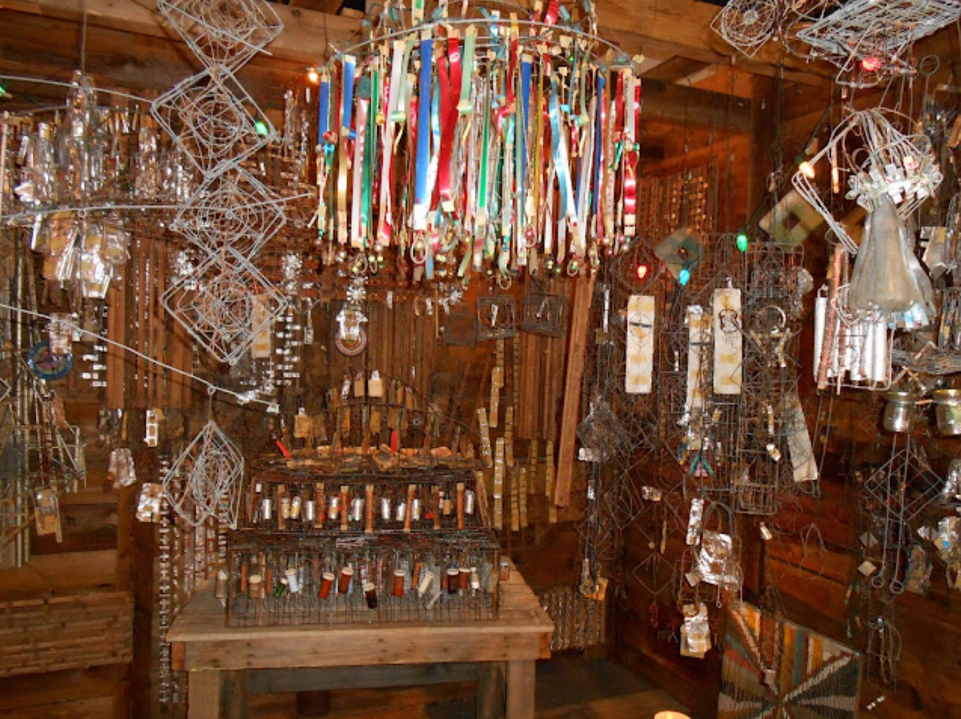

Placemakers and 'Artist Built Environments'
For centuries people have made their homes and gardens into homages and of and to their own tastes. Usually however the historical environments which remain for us to see are those who have had enough money to preserve them and preserve them into the next generation. Over the last hundred years artists (maybe who don't even define themselves as artists) from more limited means and often with no formal arts education have made their own imaginative realms using found and recycled objects to create their own worlds, often only to please themselves. Now some of these incredible places have been preserved and being recognised as the incredible artworks that they are, often only seen after the artists' deaths.
If you could make your own place purely for yourself what would you make? What would you use to make it if you could only use found or recycled materials? Think about what you get excited by and dream up your own imaginative realm, try and paint it. See some of these places below and explore more via this amazing online archive via Spaces.

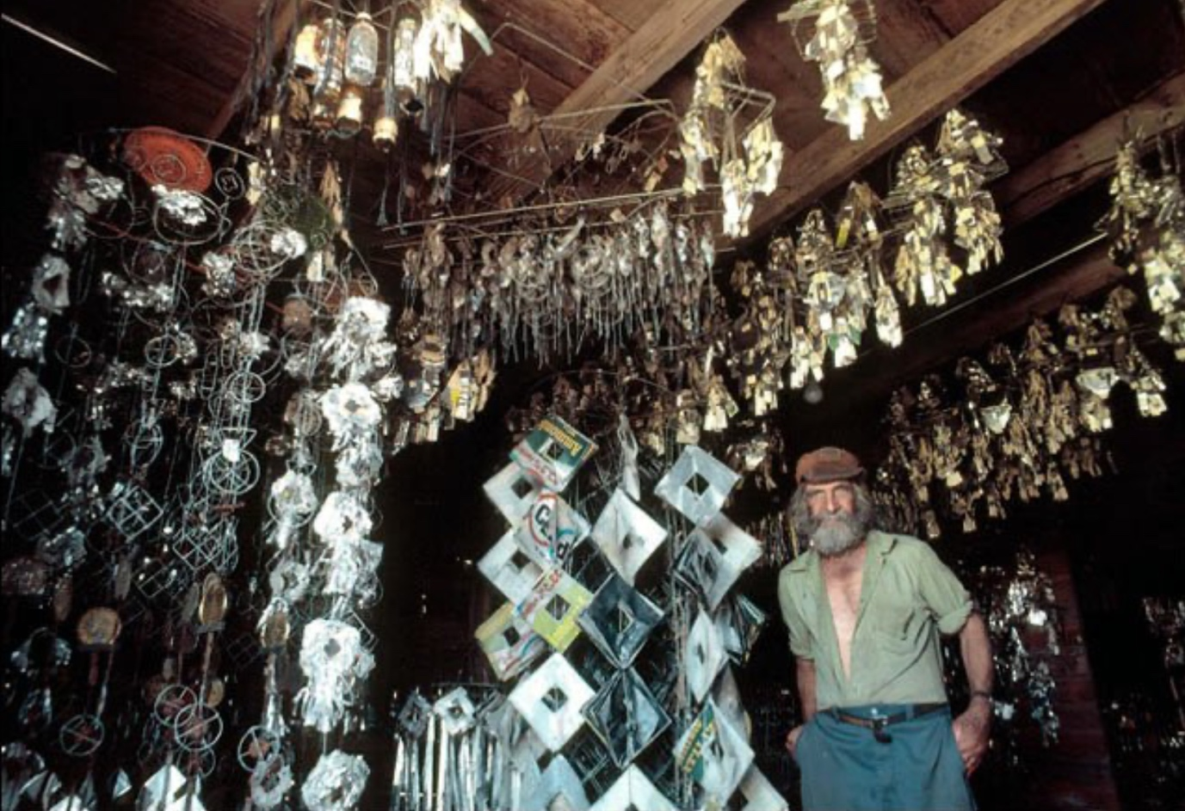
Blagdon's environment has partially been moved and preserved in a purpose built Museum in Sheboygan, Wisconsin called the Kohler Foundation, there are many others that have been saved (see image above at Kohler), have a look at other amazing environments!
"Emery Blagdon Healing Machines. "Healing Machines."
From the age of 48 in his shed in Nebraska, United States, Emery Blagdon (1907-1986) made an incredible world of intricate mobile like structures all made from copper wire, foil, ribbon, beads, magnets, and other found items, which in combination with his small rhythmic or concentrically patterned paintings, he believed could generate an electromagnetic energy that could alleviate pain and prevent—perhaps even cure—disease. He arranged the artworks in a way he believed would aid in the conduction of electromagnetic pulses in a shed.
What virtues would your environment be dedicated to? If you could change people's minds about something what might it be?

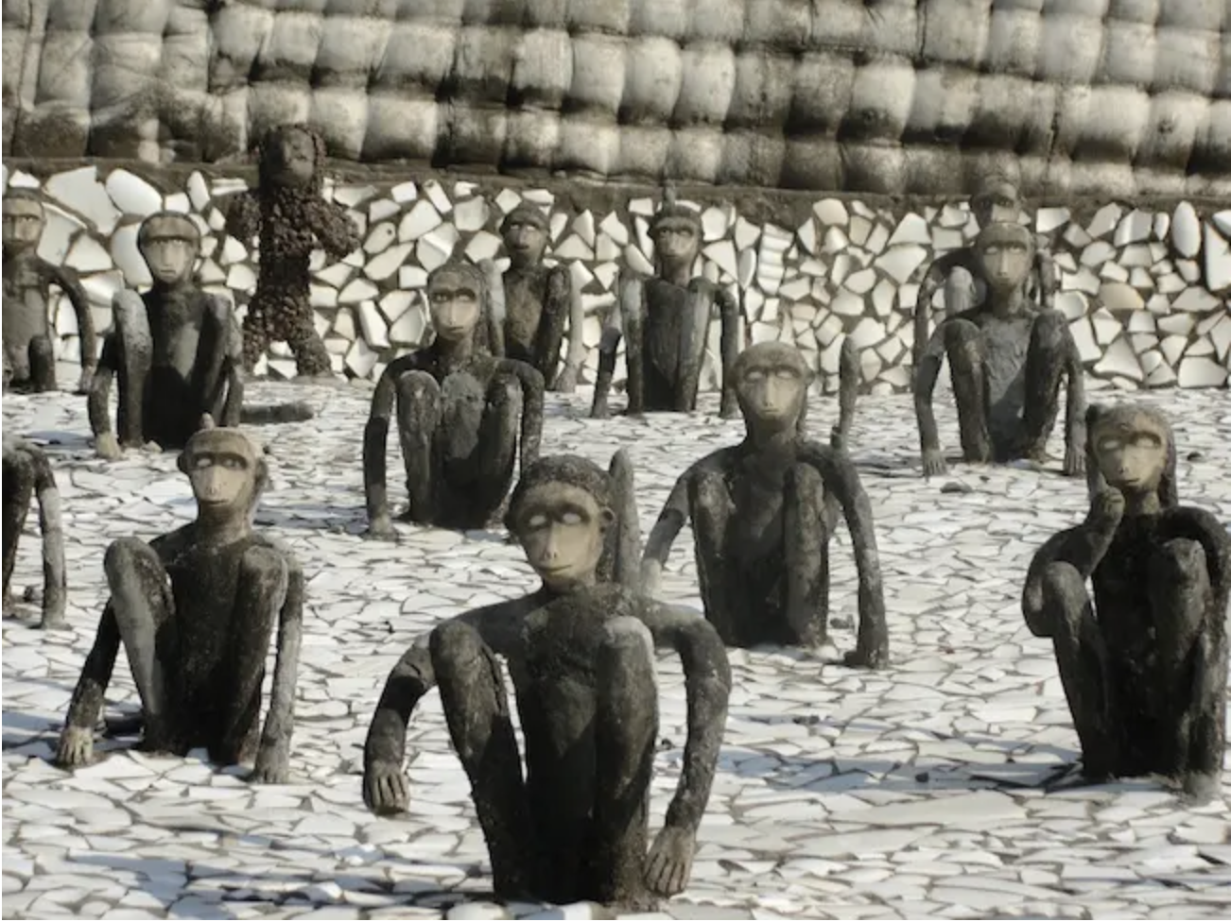

Nek Chand's Rock Garden, Chandigarh
Self-taught Indian artist Nek Chand created an extraordinary 40-acre Rock Garden inhabited by some 10,000 sculptures in the Himalayan foothills of Chandigarh, India, where the Garden is second to the Taj Mahal in attracting tourists.
Driven by the belief that everything in nature transforms itself from one form into another -- nature's way of recycling -- Chand began to collect and sort the rocks, boulders, ceramic shards, bits of broken glass, jewellery, building waste, coal, electric plug moulds, fluorescent tubes, bicycle frames, bottles, glass bangles, shells, cooking pots and smashed up bathroom fittings and clay from the remains of destroyed village to create a Rock Garden "kingdom," his personal dream and offering to the Supreme Being.
His figures of queens and courtiers, beggars and ministers, schoolchildren, revellers and dancers, monkeys, elephants and camels are set in different chambers linked by low arches and covered in mosaic. There are also hundreds of strange-shaped rocks installed in meandering lanes, two huge waterfalls, deep gorges, rushing streams, a model Punjabi village, an amphitheatre and a colonnade of giant swings.
Who or what would you create to populate your own monumental garden ? Think about what recycled and reused materials you could use to create your own world!

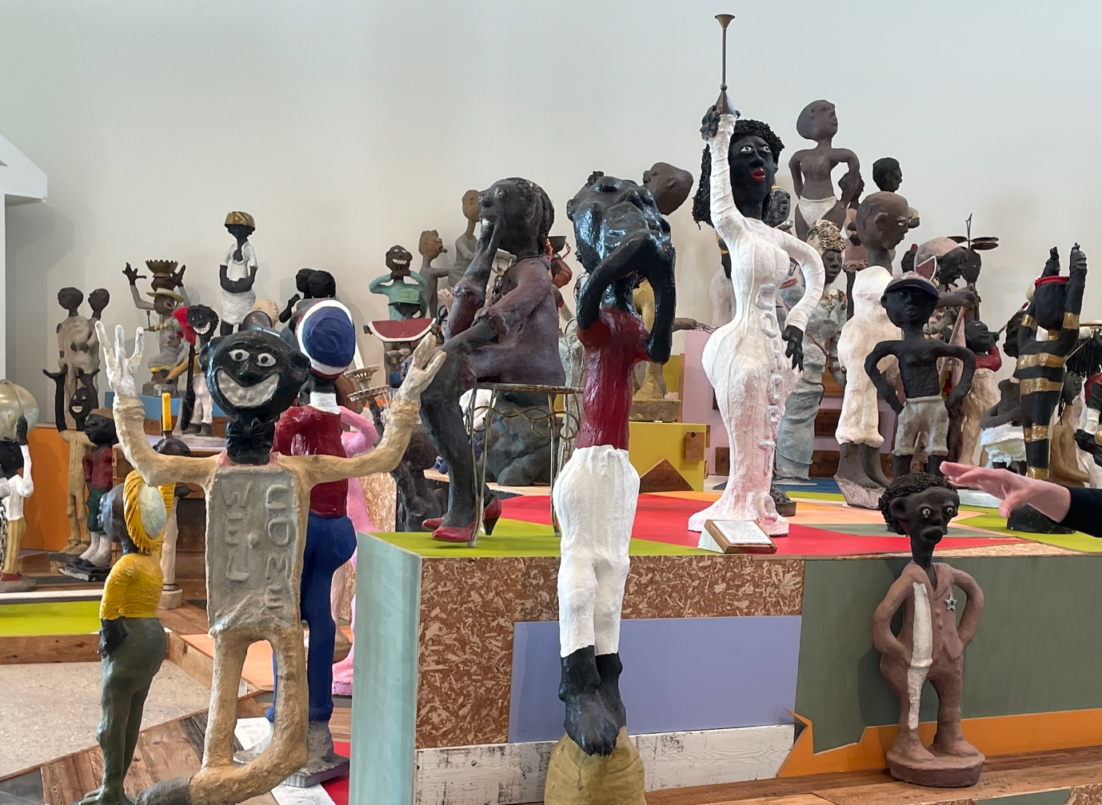

Dr. Charles Smith's African-American Heritage Museum + Black Veterans Archive
Dr. Charles Smith is still working now as an artist, activist, minister, veteran, and historian. Having became frustrated at the lack of representation of Black history he set about making figural sculptures about Black history to help create a more equitable representation and educate people about untold histories of African-American people. His sculptures show famous events in history, such as the civil rights movement, and scenes from everyday life, like a family eating dinner together. Details are often added to the sculptures in the form of found objects like hats, broken glass, and fabric. Dr. Smith’s artwork, created around his home— first in Aurora, Illinois, and currently in Hammond, Louisiana—is an artistbuilt environment that he titled African-American Heritage Museum + Black Veterans Archive. His museum is always open to visitors.
You might want to take your own home as a place of inspiration and think about all the objects and decorations that make it yours. Perhaps you have already decorated your room to represent what interests you and makes you happy. Think about what different objects mean and how you can arrange them to tell stories for others seeing them.
What would your museum be called if you made one and what would you be trying to teach through your work?

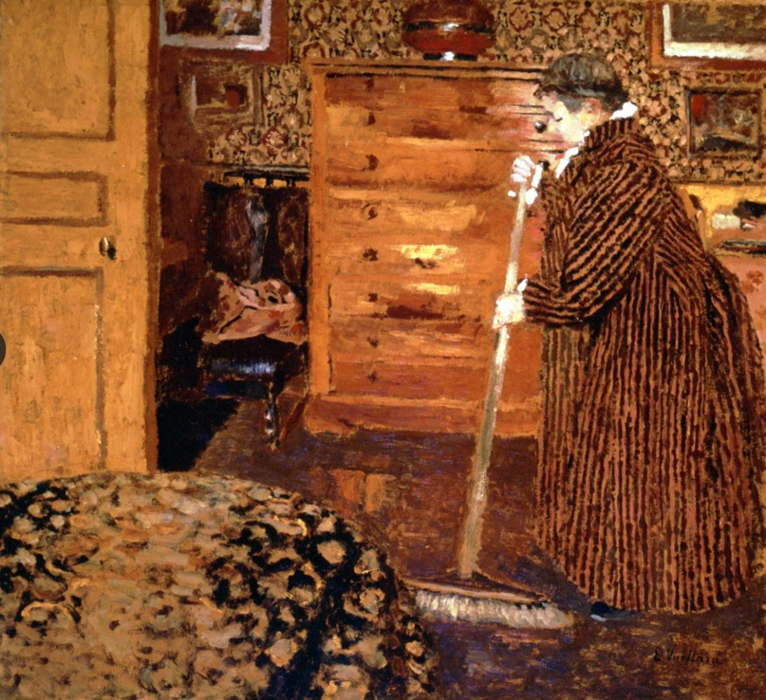
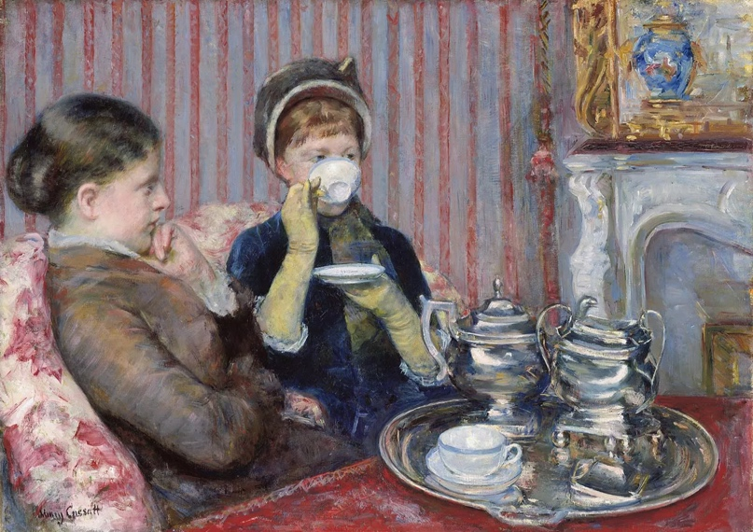

(Left) Edouard Vuillard Woman Sweeping, oil on cardboard by Édouard Vuillard, 1899–1900; in the Phillips Collection, Washington, D.C. (Right) Mary Cassatt, Five O'Clock Tea, 1880. Image via the Museum of Fine Arts Boston.
You might want to take your own home as a place of inspiration and think about all the objects and decorations that make it your home. Perhaps you have already decorated your room to represent what interests you and makes you happy. Think about what different objects mean to use and how you can arrange them to tell stories to others seeing them.
Vuillard was making art in the wake of the impressionists and interestingly decided often to depict interiors, he pays attention to every surface and texture to depict different things, he's even painted this on cardboard. Mary Cassatt who was one of the only female impressionists of note was largely restricted to paint domestic life as she was a women. Even though she was friends with Degas she wasn't allowed to go backstage at the ballet with him or to some of the cafes the male impressionists frequented. She decided to depict the woman's world with reverence and is much more sensitive than her male counterparts could have been.
Are there any places where you feel more comfortable than others, perhaps others you are curious about but don't feel yours. Art is a great excuse often to allow permission to enter different worlds you might not feel comfortable encountering. Try drawing somewhere that you've never been or draw somewhere you look and know well and see how really looking can change your perception of that place.

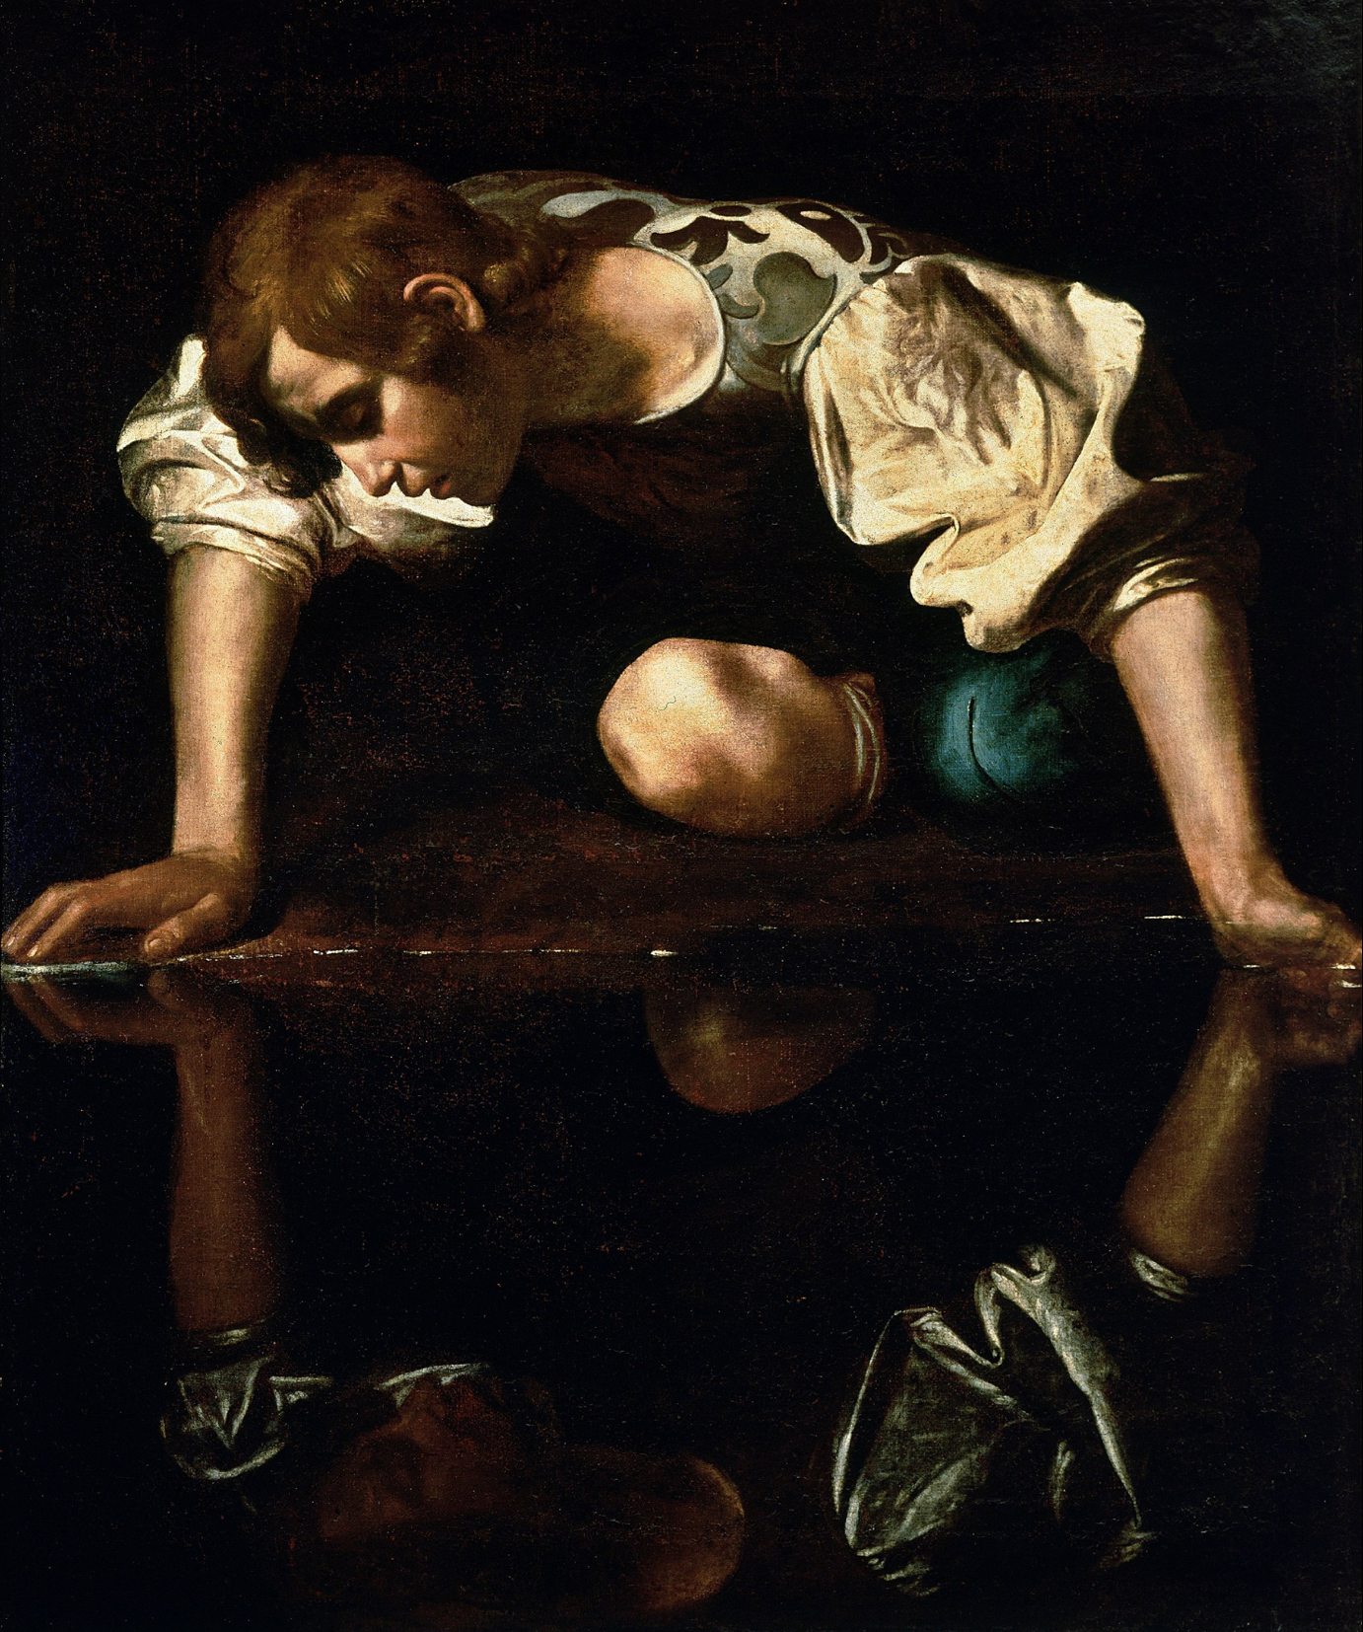

Caravaggio, Narcissus 1597-1599

Many faces throughout Art History have been based on real models but who have been playing other people like those from Greek myths and traditions to stand as allegories or perhaps cautionary tales. Narcissus famously fell in love with his own reflection and drowned, a cautionary tale as to not to value vanity.
What cautionary tales or warnings could you paint in your works? Is there a character you could make up that could be represented in such a way that could warn others not to do something or encourage others to do something positive?

EXHIBITIONS TO INSPIRE ON FACES AND PLACES IN LONDON
Try and see an artwork or an exhibition every week. When you're there stand in front of a few paintings or sculptures for much longer than you normally would. Try to ask yourself questions about who you can see but also what you might be able to smell or taste or hear or feel when looking...and try and build these sensibilities into your work.

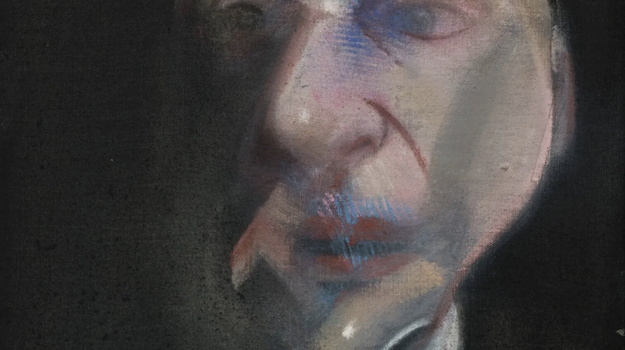
Francis Bacon at the National Portrait Gallery
If you want to see the master of modern portraiture in all its fleshyness go and see it in person at the National Portrait Gallery. You will see how innovative Bacon is with his use of perspective and how visceral and alive his subjects are! Bacon knew most of his subjects, who would you choose to paint from those who you know and would you be brave enough to be as bold as Bacon?

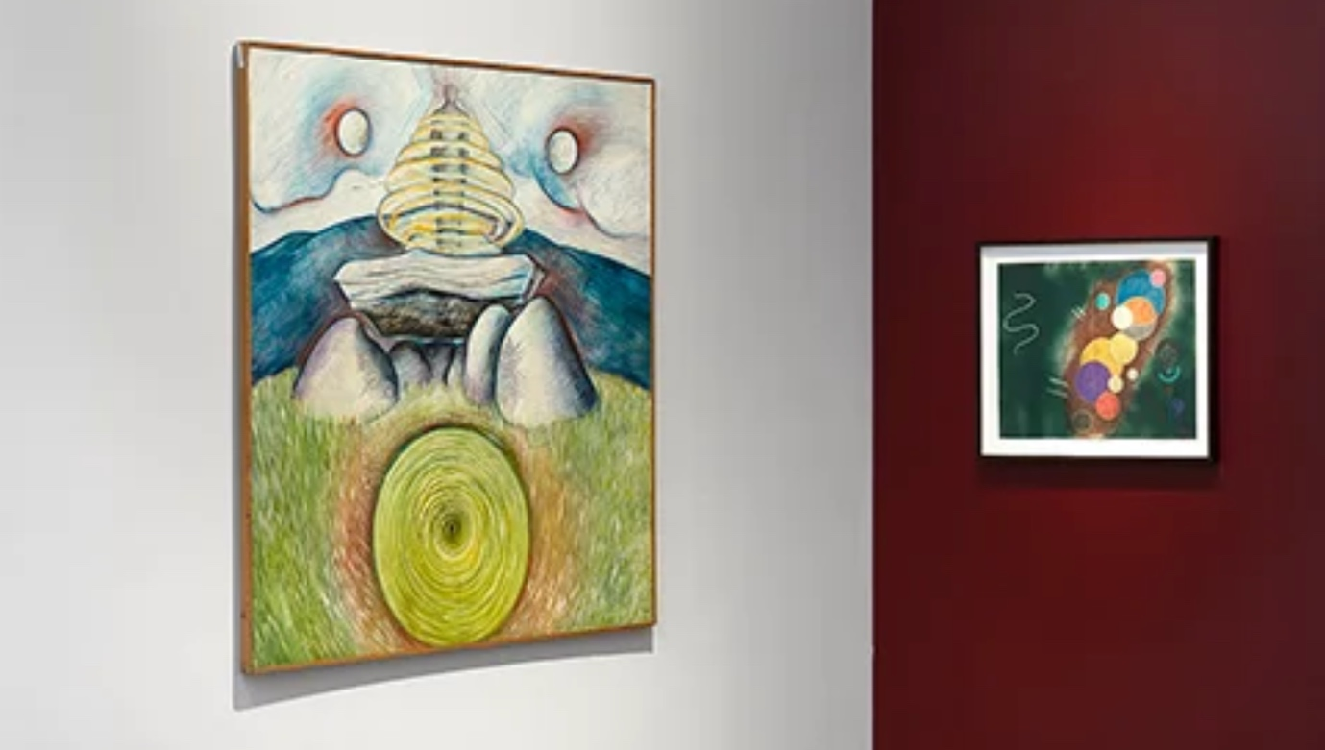

Enchanted Alchemies: Magic, Mysticism, and the Occult in Art, Lévy Gorvy Dayan, London
If you would like to see some of the surrealists in the flesh go to Lévy Gorvy Dayan's Enchanted Alchemies, an exhibition exploring themes of magic, mysticism, and the occult in art. The show features Eileen Agar, Leonora Carrington, Elda Cerrato, Ithell Colquhoun, Leonor Fini, and Monica Sjöö in dialogue with contemporary practitioners, including Francesco Clemente, Chitra Ganesh, Alejandro Jodorowsky, Bharti Kher, Linder, and Goshka Macuga.

Fundraising at your school?
If your school is organising fundraising events, we encourage you to consider YOUNG ART as your chosen charity. All donations are in aid of Great Ormond Street Hospital Charity and will go directly towards supporting vital research into childhood cancers at UCL Great Ormond Street Institute of Child Health.



Great Ormond Street Hospital Children’s Charity. Registered charity no. 1160024

